IAM-based credentials
# Source: AI Source: Provided by: [Data Path: Persons Table -> ID Column: 1, Name_En Column: Motasem Essam] -> From: [ChatGPT] on [1/18/2026]
IAM-based credentials are a type of database (or cloud service) credential that uses Identity and Access Management (IAM) policies instead of traditional usernames and passwords. They are common in cloud environments like AWS, Azure, or Google Cloud.

🔑 What They Are
# Source: AI Source: Provided by: [Data Path: Persons Table -> ID Column: 1, Name_En Column: Motasem Essam] -> From: [ChatGPT] on [1/18/2026]
- Instead of a static username/password, the system authenticates users or applications through IAM roles or policies.
- Access is granted dynamically based on the role assigned.
- Often used for temporary credentials or automatic access management.

IAM Roles and Policies
# Source: AI Source: Provided by: [Data Path: Persons Table -> ID Column: 1, Name_En Column: Motasem Essam] -> From: [ChatGPT] on [1/18/2026]
IAM Roles and Policies are fundamental concepts in cloud Identity and Access Management (IAM). They control who can do what on which resources without using traditional static passwords. Let me break it down clearly.

1️⃣ IAM Policy
# Source: AI Source: Provided by: [Data Path: Persons Table -> ID Column: 1, Name_En Column: Motasem Essam] -> From: [ChatGPT] on [1/18/2026]
- A policy is a set of rules that define permissions.
- It answers the question: “Who can do what on which resources?”
- Policies are usually written in JSON in cloud platforms like AWS.
Example (AWS Policy)
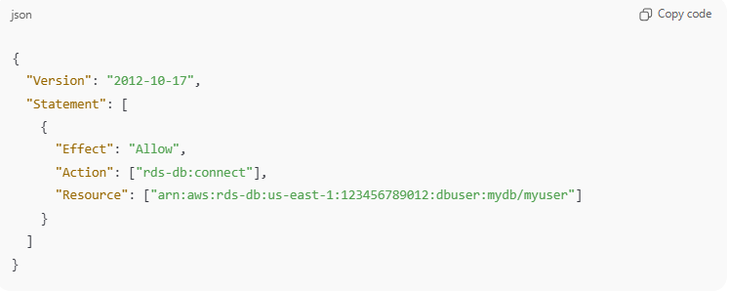
{
"Version": "2012-10-17",
"Statement": [
{
"Effect": "Allow",
"Action": ["rds-db:connect"],
"Resource": ["arn:aws:rds-db:us-east-1:123456789012:dbuser:mydb/myuser"]
}
]
}
✅ Meaning: This policy allows a specific user or role to connect to a particular database user on RDS.

2️⃣ IAM Role
# Source: AI Source: Provided by: [Data Path: Persons Table -> ID Column: 1, Name_En Column: Motasem Essam] -> From: [ChatGPT] on [1/18/2026]
- A role is a collection of permissions (policies) that can be assumed by a user, service, or application.
- Roles are temporary and assignable, so no hard-coded passwords are needed.
- Often used by applications, servers, or cloud services to access resources securely.
Example
- Role Name: AppDatabaseAccess
- Policies Attached: Can connect to RDS, read S3 bucket logs
- Who Can Assume: EC2 instance or Lambda function running the app

🔄 How Roles and Policies Work Together
# Source: AI Source: Provided by: [Data Path: Persons Table -> ID Column: 1, Name_En Column: Motasem Essam] -> From: [ChatGPT] on [1/18/2026]
- Policy = defines permissions (what actions are allowed or denied)
- Role = “container” that holds one or more policies
- User/Service assumes a role → gets permissions defined in the policies
- Temporary credentials are issued → used to access the resource

📍 Key Advantages
# Source: AI Source: Provided by: [Data Path: Persons Table -> ID Column: 1, Name_En Column: Motasem Essam] -> From: [ChatGPT] on [1/18/2026]
- No static passwords → reduces security risk
- Permissions can be fine-grained (least privilege)
- Temporary credentials → automatically expire
- Roles can be assumed by users, apps, or services flexibly

🧠 Example Use Case
# Source: AI Source: Provided by: [Data Path: Persons Table -> ID Column: 1, Name_En Column: Motasem Essam] -> From: [ChatGPT] on [1/18/2026]
- An EC2 instance needs to read data from RDS
- Attach AppDatabaseAccess role to the EC2 instance
- EC2 assumes the role → gets temporary credentials to connect to the database
- No passwords stored on the server

Example (AWS RDS)
# Source: AI Source: Provided by: [Data Path: Persons Table -> ID Column: 1, Name_En Column: Motasem Essam] -> From: [ChatGPT] on [1/18/2026]
- IAM Role: MyAppDatabaseRole
- Policies: Allow rds-db:connect to a specific database instance
- Temporary credentials are issued via AWS SDK/CLI

🛠️ How It Works
# Source: AI Source: Provided by: [Data Path: Persons Table -> ID Column: 1, Name_En Column: Motasem Essam] -> From: [ChatGPT] on [1/18/2026]
- User or application assumes an IAM role or uses an IAM user
- Cloud provider issues temporary database credentials (username + password)
- Application connects to the database using these credentials
- Credentials expire automatically, reducing risk
No permanent passwords are stored in the application.

📍 Where It’s Used
# Source: AI Source: Provided by: [Data Path: Persons Table -> ID Column: 1, Name_En Column: Motasem Essam] -> From: [ChatGPT] on [1/18/2026]
- AWS RDS, Aurora, DynamoDB
- Azure SQL Database with Azure AD authentication
- Google Cloud SQL with IAM database authentication
- Cloud-native applications and microservices

✅ Advantages
# Source: AI Source: Provided by: [Data Path: Persons Table -> ID Column: 1, Name_En Column: Motasem Essam] -> From: [ChatGPT] on [1/18/2026]
- No hard-coded passwords → reduces leakage risk
- Temporary credentials automatically expire → limits exposure
- Centralized access management via IAM roles
- Easier to rotate credentials automatically

⚠️ Disadvantages
# Source: AI Source: Provided by: [Data Path: Persons Table -> ID Column: 1, Name_En Column: Motasem Essam] -> From: [ChatGPT] on [1/18/2026]
- Requires cloud IAM setup and proper policies
- Slightly more complex to implement than User/Password
- Applications must support IAM authentication

🔒 Best Practices
# Source: AI Source: Provided by: [Data Path: Persons Table -> ID Column: 1, Name_En Column: Motasem Essam] -> From: [ChatGPT] on [1/18/2026]
- Assign least privilege roles for applications
- Use temporary credentials instead of long-lived ones
- Rotate IAM roles regularly
- Monitor and audit access via IAM logs

🧠 Authentication Factor
# Source: AI Source: Provided by: [Data Path: Persons Table -> ID Column: 1, Name_En Column: Motasem Essam] -> From: [ChatGPT] on [1/18/2026]
- Something you have → access to IAM role or credentials
- Optionally combined with something you know (for IAM user login)

